Sprint 4

|  |  |
| --- | --- |
| **TEAM ID** | PNT2022TMID08747 |
| **PROJECT DOMAIN** | Internet of Things |
| **PROJECT NAME** | IoT Based Smart Crop Protection System for Agriculture |

Command is Received through Web application:

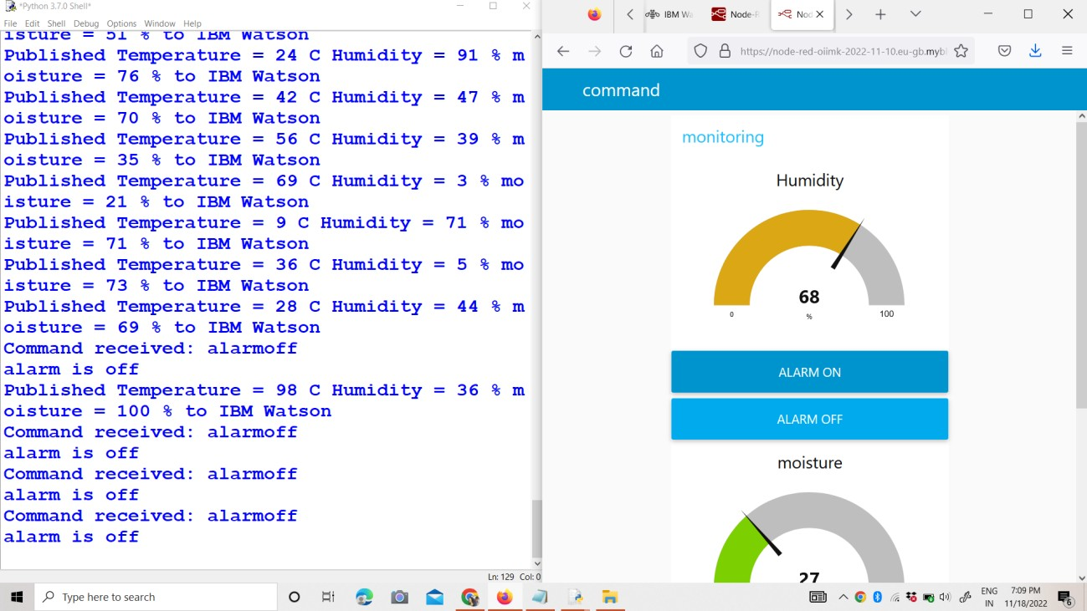

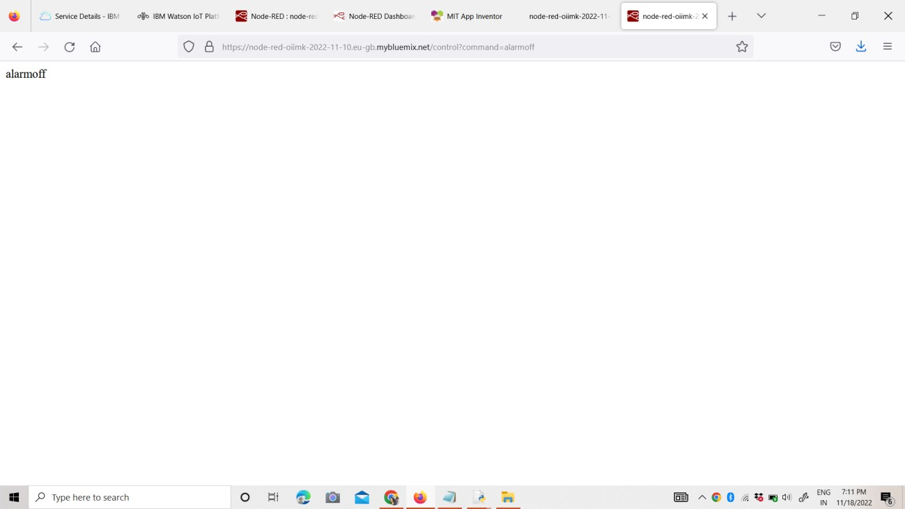

User Interface of Mobile Application:

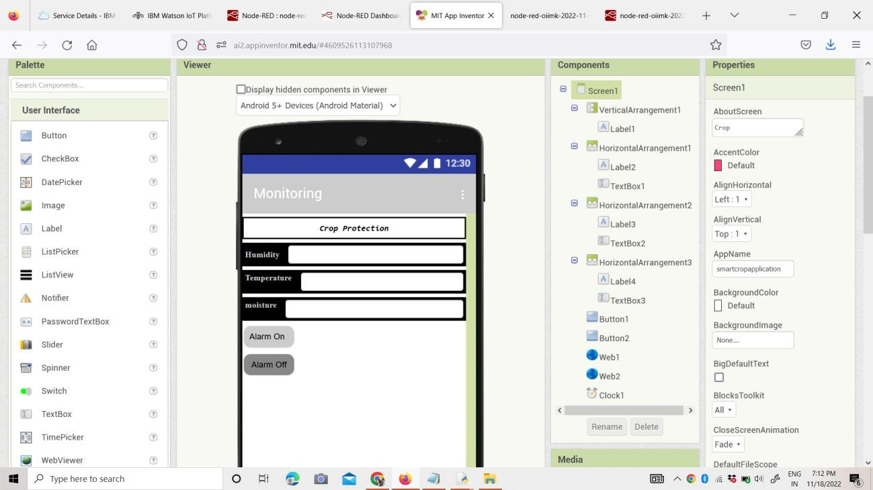

Through Sensors Buzzer will Alert the User:

